Hamon Custodis Surgical Contractor…

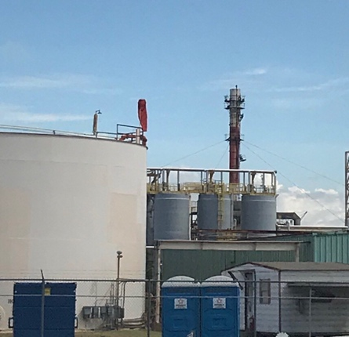
Hamon Custodis recently completed the surgical demolition of a 400 foot flare stack in the heart of an operating chemical plant on the Houston Ship Channel.

When reaching out to the many local contractors they discovered no one has the equipment, experience, or confidence to bring down the stack safely and efficiently. The few that were willing to “give it a try” approached it as a massive crane project which was both cost prohibitive and logistically daunting. It was near impossible to place a crane with the reach to support this project inside a congested process unit.

Custodis specializes in these kinds of surgical erections, demolition, inspection, and maintenance projects. Their arsenal of specialized lifting and rigging technology allows them to easily and safely access location where others are not able to go.
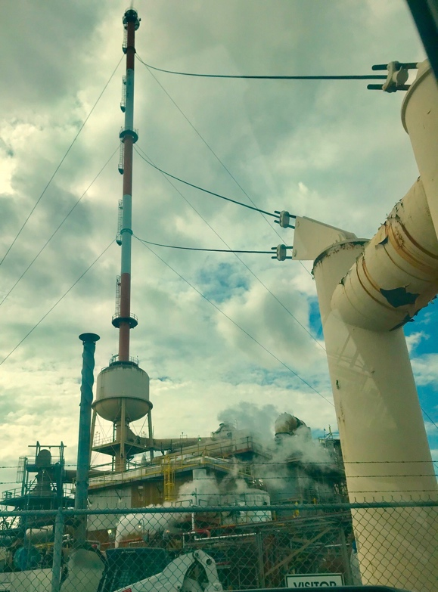
Custodis was able to engineer a rig on the OD of the stack from where the demolition could methodically disassemble the stack from the top down, lowering the pieces safely to grade for disposal. Additionally, Custodis provided a secondary team for the abatement of lead paint. The abatement and demolition team worked together in stages to mitigate the lead dangers and provide a safe, methodical execution plan.

The project was estimated to take four months and include four major guy-wire disassembly’s midway down the stack. The Custodis team successfully wrapped-up the project in only three and a half months without incident and at a fraction of the cost of a mega-crane rental rate.

If and when you have a complex challenging construction, cleaning, or demolition scope, let Custodis have a look. They may have some options and/or technology worth considering.

